Low Level Design (Login Module)

Project Code | Team1
Project Name | Airline Reservation System

Prepared/Modified by | Role | Date of Preparation
Arati Salunkhe | Software Engineer | 16/12/2013
Reviewed by | Role | Date of Review
Ruchi Bhuta | Software Engineer | 17/12/2013
Approved by | Role | Date of Approval
Chinmay Bhopalkar | Team Leader
Circulation List | arati.salunkhe@capgemini.com,  chinmay.bhopalkar@capgemini.com,  karan.motwani@capgemini.com,  namrata.gudage@capgemini.com,  ruchi.bhuta@capgemini.com,  saurabh.mhatre@capgemini.com | Version Number of the template:1.0
Version Number | 1.4

Table of Contents

1. Description Of The Unit 3
2. References 4
3. Dependencies / Assumptions 5
4. Class Diagrams 6
5. Sequence Diagrams 7
6. Design Components 8
a. List Of UI Components 8
b. List Of Design Classes 9
7. Re-Usable Routines/Components 10
8. Messages 11
9. Configuration Files 12
10. Crud Matrix Table 13
11. Data Mapping Matrix 14
12. Action Flow Matrix 15
13. Stored Procedures 16
14. Program Specification / Pseudo Code 17
REVISION HISTORY OF THE WORK PRODUCT 19

Description Of The Unit

The login module allows the users of the application to login into the system using their valid credentials.

The username and password entered by the user is validated from the database. If the entered credentials are valid then he/she is redirected to their respective pages based on their roles. Admin is redirected to Admin Page where options are provided to add, update and cancel a Flight. Executive is redirected to Executive Page where he/she can view all the flight’s seat availability, using view by date or view by source and destination function. User is redirected to User’s Home Page where he/she can search/book/cancel flight tickets.

If the entered credentials are invalid then he/she is redirected to the login page and an appropriate error message is displayed.

2 References

Reference | Description
Repository reference | https://IGTEBLRSVNTNG.igatecorp.com/svn/oct3_Team1
Class Diagram | /Project Documents/Design Documents/HLD/Class Diagrams
URS | /Project Documents/Requirements/Case Study/AirlineReservation-grp1.doc
UTP | /Project Documents/Test Plan/UTP/Test Cases/Login Module/UTP_LoginModule.xls
DB Design | /Project Documents/Design Documents/HLD/DB Design/E-Commerce_GROUP_DBDESIGN.xls

Dependencies / Assumptions

Dependencies:
This module is dependent on the registration module wherein the user details are taken and stored in the database.

Assumptions:
The user details are stored in the database through registration module whereas admin/executive valid credentials are already existing in the database.

Class Diagrams

Class Diagram

Sequence Diagrams

Sequence Diagram
N/A

Design Components

List Of UI Components

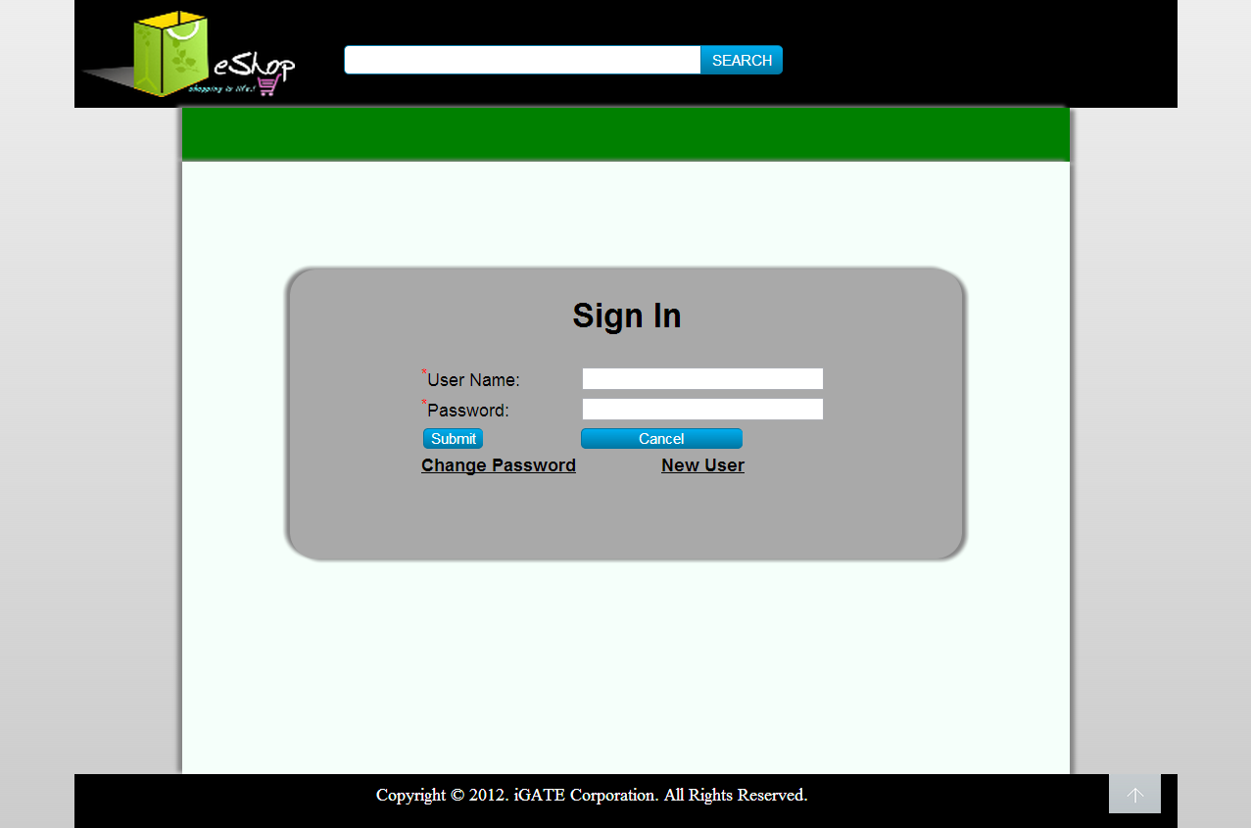

List Of Design Classes

Sr. No. | LLD Name | Class Name | Method Name | Method Description
1 | Login Module | UserClass | Appropriate getters and setters methods | Getters retrieve the property values and setters set the property values
2 | Login Module | FrontController | prepareLogin(Model model):String  checkLogin(@ModelAttribute  (value=” username”)Valid  User user,BindingResult result,Model model):String  ModelAndView authenticate(HttpServletRequest)  {  } | Sets the model attribute.  Calls isValidUser() of EshopBOImpl class, which in turn calls isValidUser() of EshopDAOImpl and if user is present it calls searchUser() to find the role and then it redirects to appropriate Pages based on the role of the user.
3 | Login Module | BookingServicesImpl | isUserAuthenticated(String userName, String password) | Calls isUserAuthenticated() of BookingServicesImpl() class which inturn gets user details from BookingDaoImpl() using getUserDetails() and checks for valid user based of details and returns the result to controller.
4 | Login Module | BookingDaoImpl | getUserDetails() | It checks for the data in users table and returns the result to the service layer.

Re-Usable Routines/Components

Re-Usable Routines/Components

- CSS files
- Javascript files
- BookingExceptions class
- Database properties files
- Logger properties files

Messages

#. | Type | Message Text
errMsg | Error | Invalid User Name/ Password

Configuration Files

File Name | Path | Description
oracle.properties | /Development/Source | To configure database connection.
Web.xml | /Development/Source | To configure the bean properties.
Dispatcher-servlet.xml | /Development/Source | To configure the request mapping and view resolver.
Eshop_logger.properties | /Development/Source | To configure the logger.
Eshop_error.properties | /Development/Source | To configure error messages.

Crud Matrix Table
# | Table Name | Create | Read | Update | Delete
1 | User | N | Y | N | N

Data Mapping Matrix

Sr. No. | Screen Label | Field Source | Field Type | Data Type | Max Length | Data Flow | Mandatory
1 | UserId | N/A | Label | N/A | N/A | UI | N/A
2 | txtUserId | User.User_id | TextBox | Varchar2 | 10 | UI→D | Yes
3 | Password | NA | Label | N/A | N/A | UI | N/A
4 | txtPassword | User.Password | TextBox | Varchar2 | 20 | UI→D | Yes
5 | Login | N/A | Button | N/A | N/A | UI | N/A
6 | Change Password | N/A | Link | N/A | N/A | UI | N/A
7 | New User | N/A | Link | N/A | N/A | UI | N/A

Legend

UI (User Interface Only)
UI → D (User Interface to Database)
D → UI (Database to User Interface)

Action Flow Matrix
Sr. No. | Action | Description | Process
1 | On click of Login Button | Valid User gets logged | Username and Password is validated from the database. If user is valid he/she is directed to respective Pages based on roles. Admin is redirected to Admin Page, Executive is redirected to executive Page and User is redirected to User’s Home Page.

Stored Procedures

# | Stored Procedure Name  (with Description) | Input/Out Parameters | Type | Size
1. | NA | NA | NA | NA

Program Specification / Pseudo Code

14. 1 <ACTION: ONPAGE_LOAD>

Pseudo Code:

- Client Side Scripting
None
- Server Side Scripting

BEGIN
Call Login(Model model) in AController class.
Navigates to Login Page.
END

14. 2 <ACTION: LOGIN_CLICK>

Pseudo Code:

- Client Side Scripting:

IF UserId isEmpty
Print Error Message M1
IF Password isEmpty
Print Error Message M1
IF invalid UserId
Print Error Message M1
IF invalid Password
Print Error Message M1

/*IF length of UserId > 10 characters
Print Error Message M1
IF length of Password > 16 characters
Print Error Message M1*/

- Server Side Scripting:
BEGIN
Call checkLogin(@ModelAttribute(value=” username”)ValidUser user,BindingResult result,Model model) in EshopController class in Presentation Layer
BEGIN
Call isValidUser(User user) in EshopBOImpl class in Service Layer
BEGIN
Call isValidUser(User user) in EshopDAOImpl class in Service Layer
BEGIN
Create query to search if the user exists or not
END
Return int to EshopBOImpl
END
Return int to EshopController class
END
If return==1
BEGIN
Call searchUser(User user) in EshopBOImpl class in Service Layer
BEGIN
Call searchUser(User user) in EshopDAOImpl class in Service Layer
BEGIN
Create query to retrieve the role of the user
END
Return role to EshopBOImpl
END
Return role to EshopController class
Navigate to respective pages based on their roles
Else navigate to login page
END
REVISION HISTORY OF THE WORK PRODUCT
# | Date | Version # | Section Changed | Details of changes made | Approved By
1 | 16/12/2013 | 1.0 | Document prepared | N/A | Uma M Ponniamman
2 | 17/12/2013 | 1.1 | List of design classes  Data Mapping Matrix | The controller’s name is changed to “EshopController”  Change Password field added | Uma M Ponniamman
3 | 18/12/2013 | 1.2 | Reusable components,  References,  Data Mapping Matrix. | Reusable Components added.  File name with relative path is added in the references section.  The name of text boxes(screen label is changed). | Uma M Ponniamman
4 | 20/12/2013 | 1.3 | Messages | Changes made in Error Messages | Uma M Ponniamman
5 | 24/12/2013 | 1.4 | Configuration files,UI Components | Paths of the configuration files is updated and UI components(Screen Shots) added. | Uma M Ponniamman

